Instructions for Filter:

Write a program that asks the user to enter an image file, loads that file and applies the “GITAM-Python” filter.
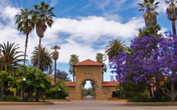

To apply the GITAM-Python filter, you are going to change every pixel to have the following new red, green and blue values, based off the pixels old red, green and blue values:
new red value = old red value * 1.5
new green value = old green value * 0.7
new blue value = old blue value * 1.5

